

American International University-Bangladesh (AIUB)
Department of Computer Science
Faculty of Science & Technology (FST)

Weather Forcasting Management System
Semester: Spring 25-26

Group: |  | Section: BB
SL | Student Name | Student ID
1 | Md Abu Eusuf | 22-48124-2
2 | Nosrat Jahan Esha | 23-50997-1
3 | Mirza Sultana Yeasmin Shova | 23-51000-1
4
5

Table of Contents

1. Project Proposal xx
1.1 Background to the Problem xx
1.2 Selection of Process Model xx
2. Timeline Chart / Gantt Chart ………………………….………………………………………………………………...xx
3. PRD xx
3.1 Functional Requirements xx
3.2 Non-Functional Requirements xx
4. Software Design xx
4.1 System Deisgn xx
4.2 UI Deisgn using Figma xx
5. Git Workflow xx
6. Software Testing xx
7. Conclusion xx

1. PROJECT PROPOSAL

  - Background to the Problem

Weather affects nearly every aspect of our daily lives, from the clothes we choose to wear to how nations organize agriculture, transportation, and disaster response. In many developing areas, people often depend on outdated or inaccurate weather reports from television or radio. Sudden, unpredictable changes in climate—such as heavy rain, storms, or heatwaves—can disrupt travel, destroy crops, and threaten lives. To tackle these issues, our team is creating the Weather Forecasting Management System (WFMS): an easy-to-use, dependable web platform that delivers real-time, accurate weather information using reputable weather APIs. The system will present live data such as temperature, humidity, chance of rain, and wind speed, enabling users to make smart choices for both daily routines and work. By fostering greater weather awareness and preparedness, WFMS seeks to minimize risks, enhance planning, and strengthen support for communities and industries reliant on weather conditions.

  - Selection of Process Model

Agile methodology is a good fit for this project due to its modular features, ongoing user engagement, and changing requirements. Agile's iterative, sprint-based approach enables the early release of essential features like authentication and weather data integration. It also encourages continuous testing and feedback, enhancing both system quality and user satisfaction. Moreover, Agile’s flexibility is especially valuable when dealing with external API dependencies and UI enhancements, making it more effective than traditional models such as Waterfall.

- The project has many small independent features (login, dashboard, weather, alerts, etc.)
- Features can be developed step by step in sprints
- Requirements may change or improve over time
- The system needs continuous user feedback (UI/UX)
- It depends on API integration, which requires early testing
- Supports parallel development (frontend + backend)
- Testing can be done continuously in each phase

2. Timeline Chart / Gantt Chart
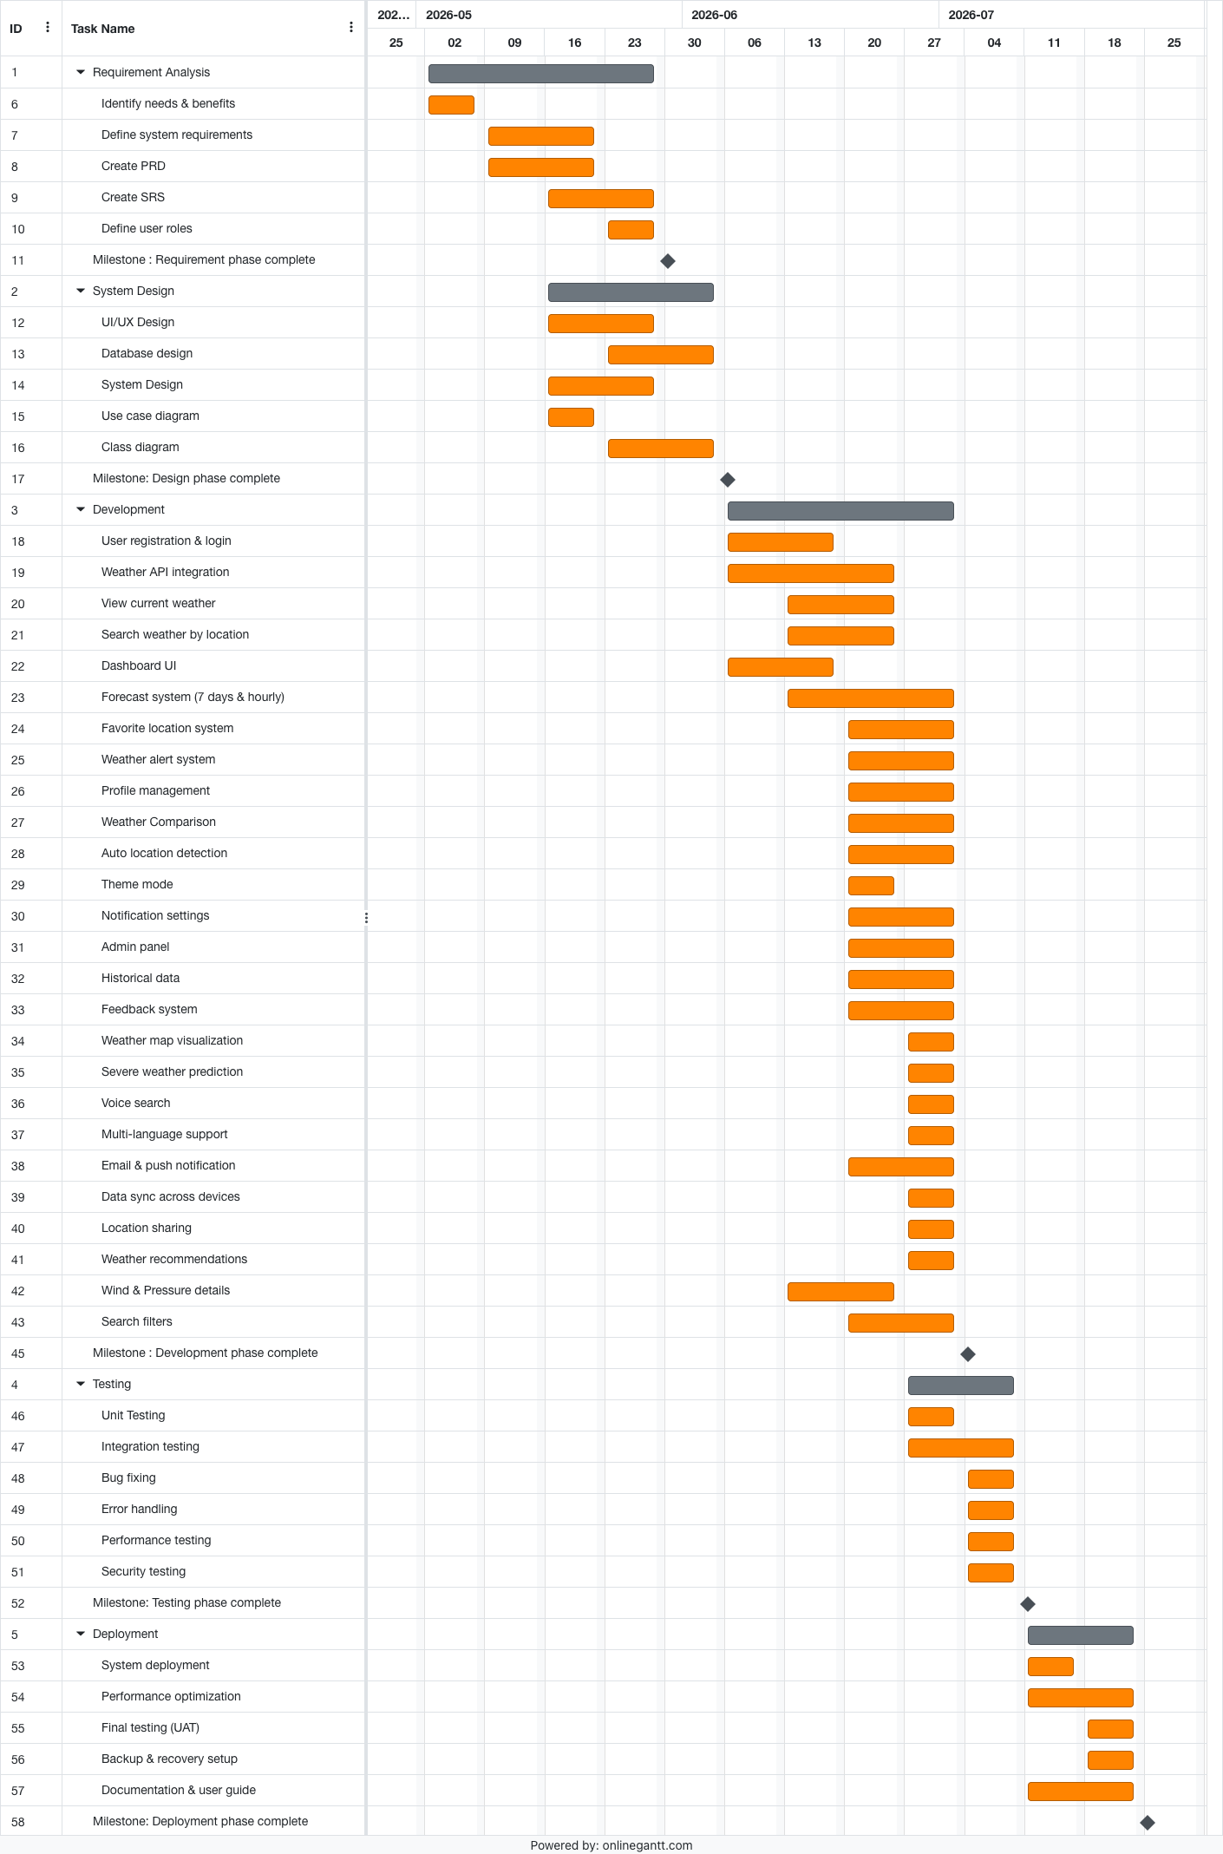

COCOMO:

Effort = PM = Coefficient_{<Effort Factor>}*(SLOC/1000)^P

= 2.4×(14000/1000)^1.05

= 38 person-month

Development time = DM = 2.50*(PM)^T
= 2.5×(38)^0.38
= 10 person-months
Required number of people = ST = PM/DM
= 38/10 person
= 3.8 persons

3. REQUIREMENTS DOCUMENT (PRD)
3.1 Functional Requirements
Item No | Feature | Specification | Screen Definition | User Story | Acceptance Criteria
1 | Landing Page | Hero Section | Header: Logo + Navigation Content:  - Tagline: "Real-Time Weather Monitoring System"  - Subheading: "Accurate and Reliable Forecast"  - Background: Weather animation (clouds/rain)  - CTA: Search Weather | As a visitor, I want to quickly understand the system so that I can use it easily | -Page fully loads in under 3 seconds on standard connections  -The CTA button ("Search Weather") is visible without scrolling on all screen sizes  -Layout is responsive across desktop, tablet, and mobile  -Weather animation (clouds/rain) plays smoothly without blocking content
2 | User Registration | Create  Account | Input fields:-  -Name  -Email  -Password  -Confirm Password Submit Button | As a user, I want to register so I can access personalized features | -Email field validates proper format (e.g., user@example.com); invalid formats show an inline error  -Password must be at least 8 characters, include uppercase, lowercase, a number, and a special character  -Confirm Password field must match the Password field; mismatch shows an error  -All fields show clear, descriptive error messages for invalid input  -Successful registration redirects the user or shows a confirmation message
3 | User Login | Authentication | Input fields:  -Email  -Password  -Login Button  -Forgot Password option | As a user, I want to log in securely to access my account | -User can log in with a valid registered email and password  -Incorrect credentials display a descriptive  error (e.g., "Invalid email or password")  -"Forgot Password" option navigates to a password recovery flow  -Successful login redirects to the Dashboard
4 | Dashboard | Main Interface | Components:  - Current Weather Panel  - Search Bar  - Saved Locations  - Navigation Menu | As a user, I want a dashboard to view weather info quickly | -Dashboard loads all components (Current Weather, Search Bar, Saved Locations, Navigation) within 2 seconds  -UI is fully responsive and usable on all device sizes  -Components display placeholder/loading states while data is being fetched
5 | Search Weather | Location Search | Input:  - City name  Output:  - Weather result display | As a user, I want to search weather by location | -Searching for a valid city name returns correct weather data  -Searching for an invalid or unknown location shows a friendly error message (e.g., "Location not found")  -Search results display within 2 seconds of submission
6 | Current Weather | Real-Time Data | Display:  - Temperature  - Humidity  - Wind Speed  - Weather Condition Icon | As a user, I want to see current weather details | -Temperature, Humidity, Wind Speed, and Weather Condition Icon are all displayed  -Data refreshes in real-time (or at defined intervals, e.g., every 10 minutes)  -Data values match the external API response with no transformation errors
7 | Weather Forecast | Forecast System | Components:  - 7-day forecast  - Hourly forecast  - Graph/Icons | As a user, I want to see future weather predictions | -7-day forecast and hourly forecast are both visible and clearly labeled  -Forecast data is displayed with icons and/or graphs that are easy to read  -Data accuracy is maintained as per the connected weather API
8 | Favorite Locations | Save Feature | Buttons:  - Add to Favorites  - Remove from Favorites List  -View of saved places | As a user, I want to save locations for quick access | -The user can add a location to favorites; it appears immediately in the saved list.  -The user can remove a location; it is removed immediately without a page reload  -Saved locations persist across sessions (after logout and re-login)
9 | Weather Alerts | Notification System | Alerts:  - Rain warning  - Storm alert  - Severe weather notification | As a user, I want to receive important alerts | -Alerts (rain, storm, severe weather) are triggered based on API forecast thresholds  -Notifications are visible to the user without requiring a page refresh  -Each alert clearly identifies the type of weather event and the affected location
10 | Profile Management | User Profile | Features:  - View profile  - Update info  - Change password | As a user, I want to manage my account | -User can view and edit their name, email, and other profile fields  -Updated information is saved and reflected immediately after submission  -Password change requires current password verification and follows the same security rules as registration
11 | Weather Comparison | Compare Locations | Features:  - Select multiple cities  - Display comparison chart | As a user, I want to compare weather data | -The user can select 2 or more cities for comparison  -A comparison chart loads correctly, showing weather data side-by-side  -Chart renders within 3 seconds of selection
12 | Auto Location Detection | GPS Feature | Detect user location automatically | As a user, I want instant weather without searching | -System prompts the user for location permission before accessing the GPS  -If permission is granted, the user's current location is detected accurately, and weather loads automatically  -If permission is denied, the system falls back to manual search without errors
13 | Theme Mode | UI Customization | Toggle:  - Dark mode  - Light mode | As a user, I want comfortable viewing | -Toggling between Dark and Light mode applies instantly with no page reload  -Selected theme preference is saved and restored on the next visit/login
14 | Notification Settings | Alert Control | Settings:  - Enable/disable alerts  - Choose alert types | As a user, I want control over notifications | -The user can enable or disable alert notifications from the settings panel  -The user can choose specific alert types  -Changes are saved, and alerts follow the updated preferences immediately
15 | Admin Login | Admin Access | Secure admin login panel | As an admin, I want system access | -Admin login panel is only accessible via a specific, restricted URL or admin-designated route  -Unauthorized users attempting to access the admin panel are redirected or shown an access-denied message  -Admin login uses secure authentication (same validation as user login)
16 | User Management | Admin Control | Features:  - View users  - Delete users  - Manage roles | As an admin, I want to control users | -Admin can view a list of all registered users  -Admin can delete a user; the user is removed from the system and can no longer log in  -Admin can manage user roles; role changes take effect immediately
17 | System Monitoring | Logs & Activity | Admin dashboard:  - Logs  - Activity tracking | As an admin, I want system visibility | -Admin dashboard displays activity logs updated in real-time  -Logs include timestamps, user actions, and system events  -Admin can filter logs by date, user, or event type
18 | API Integration | Weather API | Fetch data from external API | As a system, I need real-time data | -Weather API responds within 2 seconds under normal load  -If the API fails or times out, the system shows a graceful error message (e.g., "Data temporarily unavailable")  -API errors do not crash the application; fallback/cached data is shown where possible
19 | Historical Data | Weather History | Features:  - View past data  - Filter by date | As a user, I want past weather info | -The user can view past weather data for a selected location  -Date filters work correctly and return accurate historical records  -Data loads within 3 seconds of applying filters
20 | Feedback System | User Feedback | Form:  - Submit feedback  - Store feedback | As a user, I want to give feedback | -The user can submit feedback via the form; submission is confirmed with a success message  Feedback is stored in the database and is accessible to the admin  -Empty or invalid form submissions are blocked with appropriate validation messages
21 | Weather Map Visualization | Interactive weather map with overlays | Map view with temperature, rain, wind layers; zoom & pan support | As a user, I want to view weather visually on a map | -Map loads within 3 seconds  -Temperature, rain, and wind overlay layers toggle on/off smoothly  -Zoom and pan functions without lag or rendering errors
22 | Severe Weather Prediction | Early warning system based on forecast | Alert banner + highlighted warning icons | As a user, I want early warnings for dangerous weather | -Alert banners and warning icons appear before a predicted severe weather event (based on API forecast data)  -The accuracy of alerts is tied directly to the API's forecast reliability  -Visual warning indicators are clearly distinguishable from normal alerts
23 | Voice Search Support | Search using voice commands | Mic icon + voice input popup | As a user, I want to search weather using my voice | -Voice input is recognized and processed within 2 seconds  -If voice input fails (no mic access, unrecognized input), a clear error message is shown  -Supports major languages as per the app's localization settings
24 | Multi-Language Support | Language switching option | Dropdown for language selection | As a user, I want to use the app in my preferred language | -Language changes instantly upon selection from the dropdown; no page reload required  -All UI text elements update correctly in the selected language  -No broken, missing, or untranslated text is visible after switching languages
25 | Email Notifications | Send weather updates via email | Email settings panel | As a user, I want to receive weather updates via email | -Weather update emails are sent at the scheduled time without delay  -The user can enable or disable email notifications from their settings  -No duplicate emails are sent for the same event
26 | Push Notifications | Real-time push alerts | Notification popups (mobile/web) | As a user, I want instant alerts about weather changes | -Push notifications are delivered in real-time upon triggering weather events  -Clicking a notification opens the relevant page/section in the app  -The user can disable push notifications from settings; no notifications are sent after disabling
27 | Data Sync Across Devices | Sync user data across devices | Background sync system | As a user, I want my data synced across devices | -User data (saved locations, preferences) syncs automatically across all logged-in devices  -No data loss occurs during sync  -Synced data reflects updates in real-time or within an acceptable delay (e.g., < 30 seconds)
28 | Location Sharing | Share weather info with others | Share button with link/social options | As a user, I want to share weather updates with others | -A shareable link is generated instantly when the user clicks the Share button  -The shared link works correctly across platforms (web, mobile, social media)  -The shared link displays accurate weather data for the shared location
29 | Weather-Based Recommendations | Suggest actions based on weather (e.g., carry umbrella) | Recommendation section on dashboard | As a user, I want suggestions based on weather conditions | -Recommendations (e.g., "Carry an umbrella") update dynamically based on current/forecast weather  -Suggestions are contextually relevant to the weather condition being displayed  -Recommendations section loads within 2 seconds
30 | Wind & Pressure Details | Show detailed atmospheric data | Expanded weather details section | As a user, I want detailed wind and pressure info | -Wind speed, direction, and atmospheric pressure are displayed clearly in the expanded weather section  -Values are accurate as per the API response  -Data updates in real-time alongside the current weather panel
31 | Search Filters | Filter weather search (time, condition) | Filter dropdown in search | As a user, I want filtered search results | -Filter options (by time, condition) apply instantly upon selection  -Filtered results are accurate and match the selected criteria  -No performance lag when applying or clearing filters

3.2 Non-Functional Requirements
Item | Feature | Specification | Screen Definition | Acceptance Criteria
1 | Performance | System Speed | All pages should load quickly with minimal delay | -All pages fully load within 3 seconds on a standard broadband connection  -API responses are returned within 2 seconds under normal server load  -The weather dashboard renders all components (current weather, forecast, map) within 3 seconds  -No single UI operation blocks the main thread for more than 500ms  -Lazy loading is implemented for non-critical components to reduce initial page load time  -System performance is verified via load testing tools (e.g., JMeter or Lighthouse) before release
2 | Availability | System Uptime | System should be accessible at all times | -System maintains ≥99% uptime measured every month  -Planned maintenance windows are communicated to users at least 24 hours in advance. The s  -The system automatically recovers from server failures without requiring manual intervention.  -Health-check monitoring endpoints respond within 1 second at all times  -Downtime notifications are displayed to users via in-app banners or a status page  -Failover mechanisms are in place so that a single server failure does not cause a full outage
3 | Security | Data Protection | Secure login and encrypted data handling | -All user passwords are hashed using a strong algorithm (e.g., bcrypt with salt rounds ≥10)  -All data transmitted between client and server uses HTTPS with TLS 1.2 or higher  -No plaintext passwords or credentials are stored anywhere in the database or logs  -Unauthorized access attempts are detected and blocked after 5 consecutive failed login attempts  -JWT or session tokens are signed, time-limited, and invalidated on logout  -Regular security audits or vulnerability scans are conducted at least once per quarter
4 | Usability | User Experience | Simple and intuitive interface design | -A first-time user can complete core tasks (register, search weather, view forecast) without external guidance  -All interactive elements (buttons, links, inputs) have clear labels, tooltips, or placeholders  -The navigation menu is consistently placed and accessible from every screen  -UI design follows a consistent color scheme, typography, and spacing throughout the application  -User testing confirms a task completion rate of ≥90% for all primary user flows  -Error messages are written in plain language and include guidance on how to resolve the issue
5 | Reliability | System Stability | System should function without crashes | -System operates without crashes or unhandled exceptions under normal usage conditions  -Mean Time Between Failures (MTBF) is at least 720 hours (30 days) under normal load  -All runtime errors are caught by error boundaries and logged with full context  -Automatic error recovery restores the affected component without requiring a full page reload  -System is stress-tested to confirm stability at 150% of the expected peak concurrent users  -Critical system failures trigger automated alerts to the development/admin team within 5 minutes
6 | Scalability | System Growth | System should handle increasing users/data | -System supports at least 1,000 concurrent users without performance degradation  -Server infrastructure supports horizontal scaling (adding more instances under load)  -The database is designed to handle growing data volumes with indexing and query optimization  -Load balancing is configured so that traffic is distributed evenly across server instances  -System is tested at 150% of expected peak load; performance benchmarks remain within acceptable limits  -Cloud/server auto-scaling policies are configured to activate when CPU usage exceeds 70%
7 | Maintainability | Code & System Maintenance | Easy to update and maintain system | -Codebase follows a defined coding standard (e.g. ESLint/Prettier rules) enforced via CI pipeline  -All modules and services are independently deployable without breaking other components  -Inline code documentation and README files are available for all major modules  -A new developer can understand the project structure and make a minor fix within 2 working days  -Unit and integration tests cover at least 70% of the codebase to catch regressions  -Dependency updates and patches can be applied without redesigning core functionality
8 | Compatibility | Device Support | Works on different devices and browsers | -Application functions correctly on Chrome, Firefox, Edge, and Safari (latest 2 major versions each)  -UI is fully responsive and usable on iOS and Android mobile devices  -No critical layout breaks or UI distortions appear at screen widths between 320px and 2560px  -All core features work on both Windows and macOS operating systems  -Application passes cross-browser testing using tools such as Browser Stack or similar  -Touch interactions (tap, swipe) work correctly on mobile and tablet devices
9 | Data Accuracy | Data Quality | Weather data should be accurate and updated | -Weather data values displayed match the external API response with zero transformation errors  -Current weather data refreshes automatically at defined intervals (e.g. every 10 minutes)  -Stale data older than the defined threshold triggers a refresh or displays a visible warning to the user  -Forecast data is validated against the API response schema before being rendered on screen  -Historical weather data is stored accurately with correct timestamps and location identifiers  -Data integrity checks are run on API payloads; malformed responses are rejected and logged
10 | API Reliability | External Integration | Stable API connection for weather data | -External weather API maintains a success rate of ≥95% for all outgoing requests  -Failed API calls are automatically retried up to 3 times with exponential backoff before fallback  -Cached or previously fetched data is displayed during API outages without crashing the system  -API request timeouts are set to a maximum of 5 seconds to prevent indefinite waiting  -API key rotation and quota monitoring are implemented to prevent service interruptions  -System logs all API failures with timestamp, endpoint, status code, and error message for debugging
11 | Error Handling | Fault Management | System handles errors gracefully | -All errors display user-friendly messages written in plain language; no raw stack traces are shown  -Each error message clearly identifies what went wrong and suggests a corrective action where possible  -Invalid user inputs (e.g. empty fields, wrong formats) are caught client-side before submission  -All backend errors are logged with full context: timestamp, user ID, route, HTTP status, and error message  -Application does not crash on unhandled errors; error boundaries catch and display fallback UI  -Error recovery does not require a full page reload in at least 90% of non-critical error cases
12 | Privacy | User Data Privacy | Protect personal user information | -User personal data is never shared with third parties without explicit user consent  -A clear and accessible privacy policy is displayed to users before account creation  -All personally identifiable information (PII) is stored in encrypted form in the database  -Users can request full deletion of their account and all associated data at any time  -System complies with applicable data protection regulations (e.g. GDPR or local equivalents)  -Data access is restricted by role; only authorized personnel can view user records
13 | Backup & Recovery | Data Safety | System should support backup & recovery | -Automated database backups are scheduled and run at least once every 24 hours  -Backups are stored securely in a separate physical or cloud location from the primary server  -Backup integrity is verified automatically after each backup cycle  -Full system recovery from the latest backup can be completed within 4 hours of a critical failure  -Recovery process is documented and tested at least once every 6 months  -Admin is notified immediately if a scheduled backup fails
14 | Response Time | System Interaction Speed | Fast interaction between user & system | -All button clicks and UI interactions produce visible feedback within 1 second  -Search results begin rendering within 2 seconds of query submission  -Form submissions return a success or error response within 2 seconds  -Navigation between pages or sections completes within 1 second  -No user-initiated action results in a visible freeze or spinner lasting more than 3 seconds  -Loading indicators are shown immediately for any operation expected to take more than 1 second
15 | Accessibility | Inclusive Design | System usable for all users | -System meets WCAG 2.1 Level AA accessibility standards across all pages  -All features are fully navigable using keyboard alone (Tab, Enter, Escape, Arrow keys)  -All interactive elements have descriptive ARIA labels readable by screen readers  -Text color contrast ratio meets the minimum 4.5:1 ratio required by WCAG AA  -Images and icons include meaningful alt text describing their purpose  -Accessibility compliance is verified using automated tools (e.g. Axe or Lighthouse) before each release
16 | Localization | Multi-Language Support | UI supports multiple languages | -System supports at least 3 languages from launch (e.g. English, Bengali, Arabic)  -Language switching takes effect instantly upon selection with no page reload required  -All UI strings, labels, error messages, and notifications are stored in external translation files  -No broken, missing, or untranslated text appears after switching languages  -Date, time, and number formats are localized according to the selected language/region  -New languages can be added by updating translation files without modifying source code
17 | Logging | Activity Tracking | System logs user and admin activities | -All user actions (login, logout, search, and settings changes) are logged with a timestamp and a user ID  -All admin actions (user deletion, role changes, system configuration) are separately logged  -Error logs capture full context: timestamp, user ID, route, HTTP status code, and stack trace  -Logs are retained for a minimum of 90 days and are searchable and filterable by the admin  -Log data is stored securely, and access is restricted to authorized admin roles only  -Real-time log monitoring alerts the admin team when critical error thresholds are exceeded
18 | Session Management | User Sessions | System handles login sessions securely | -User sessions automatically expire after 30 minutes of inactivity  -Users are warned 5 minutes before session expiry and given the option to extend  -Secure, signed session tokens (e.g. JWT) are used; tokens cannot be reused after logout  -Sessions are immediately invalidated on logout; subsequent requests with old tokens are rejected  -Concurrent sessions from multiple devices are tracked and manageable from the user's profile  -Session tokens are transmitted only over HTTPS and are never exposed in URLs or logs
19 | Performance Optimization | Resource Usage | Efficient memory and CPU usage | -Server-side CPU usage does not exceed 70% under normal operating conditions  -Memory consumption remains within defined limits and does not grow unboundedly over time  -Database queries are optimized with appropriate indexing; no query takes longer than 500ms  -API calls are batched or cached where possible to reduce external request volume  -Frontend assets (JavaScript, CSS, images) are compressed and served with caching headers  -Code splitting and lazy loading are applied to reduce the initial JavaScript bundle size
20 | UI Responsiveness | Screen Adaptability | UI adapts to different screen sizes | -UI layout adapts correctly to all screen widths from 320px (small mobile) to 2560px (large desktop)  -No horizontal scrollbars appear on standard screen sizes under normal content conditions  -All UI elements reflow correctly without overlapping or clipping when resized  -Touch targets on mobile devices are at least 44×44px per accessibility guidelines  -Responsive behavior is verified at standard breakpoints: 320px, 768px, 1024px, and 1440px  -Images and media scale proportionally without distortion across all supported screen sizes

4. SOFTWARE DESIGN
4.1 System Design:
Use Case:
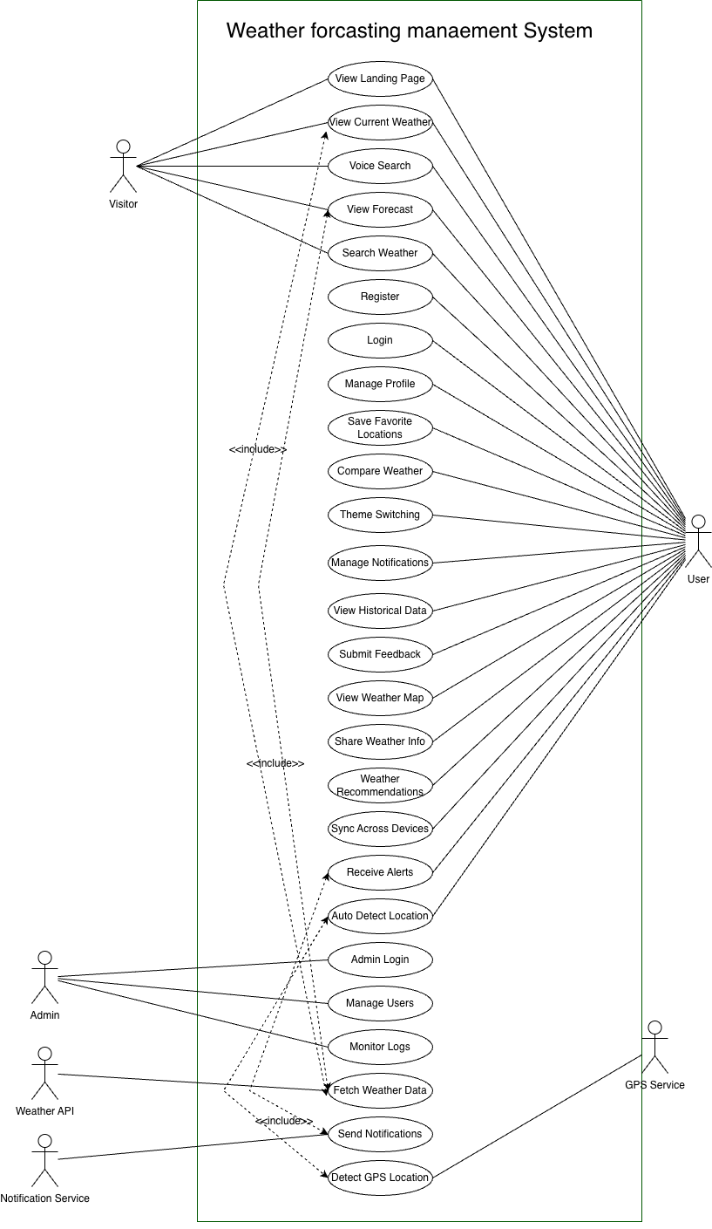
Class Diagram:
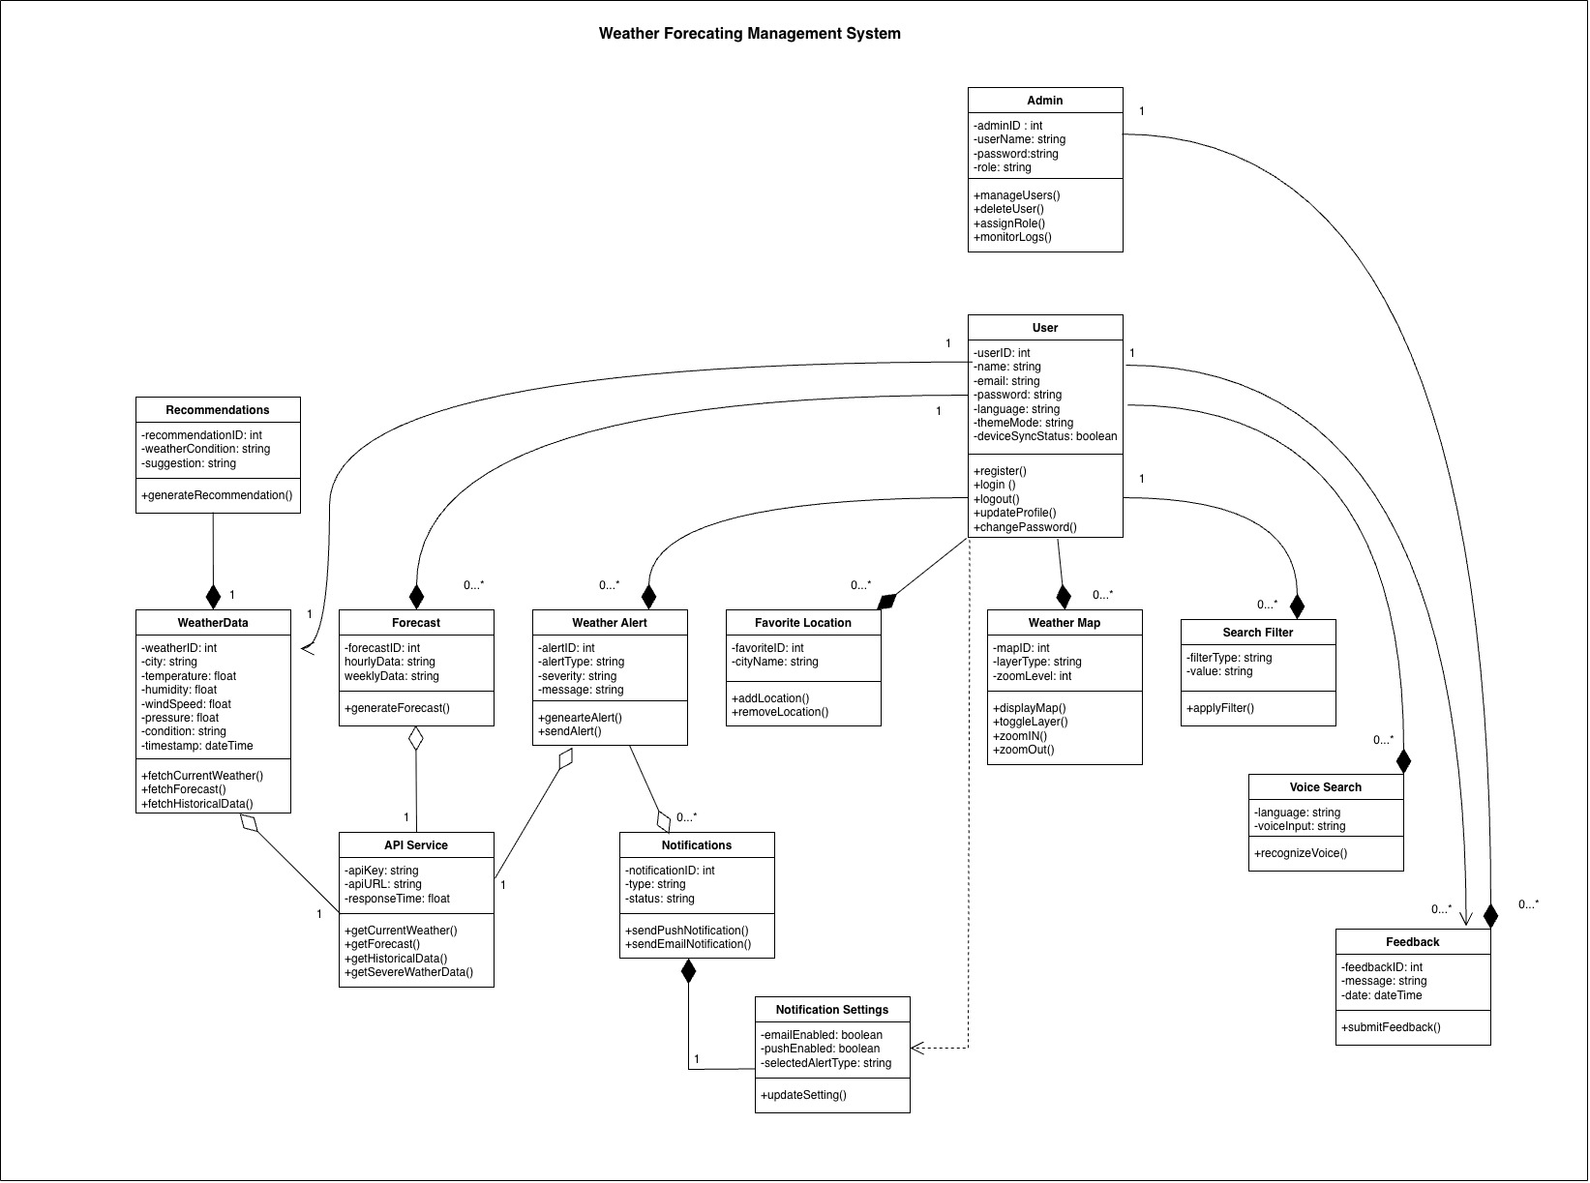

UI / Wireframe Design using Figma
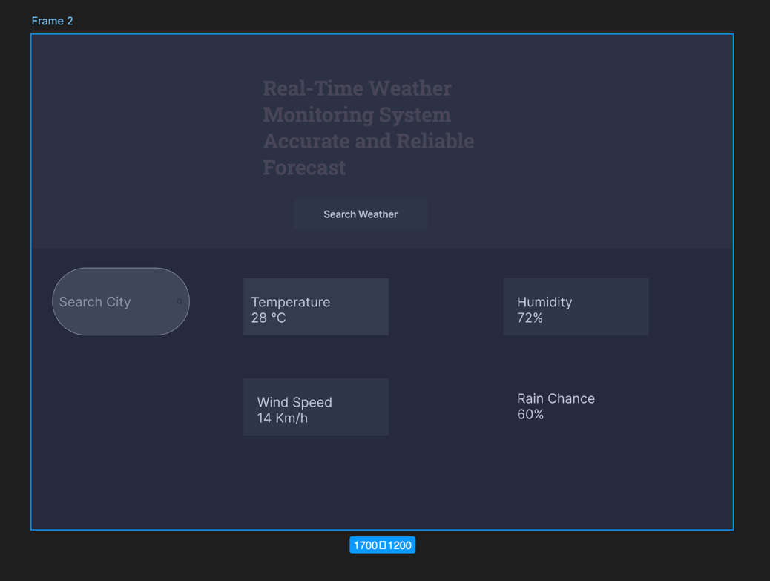
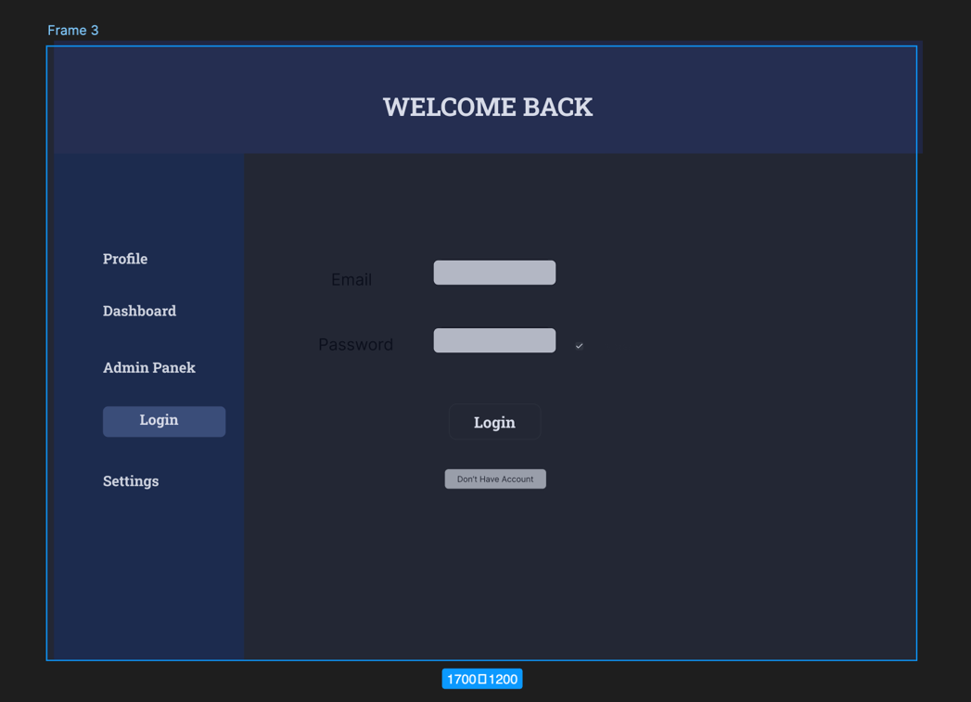
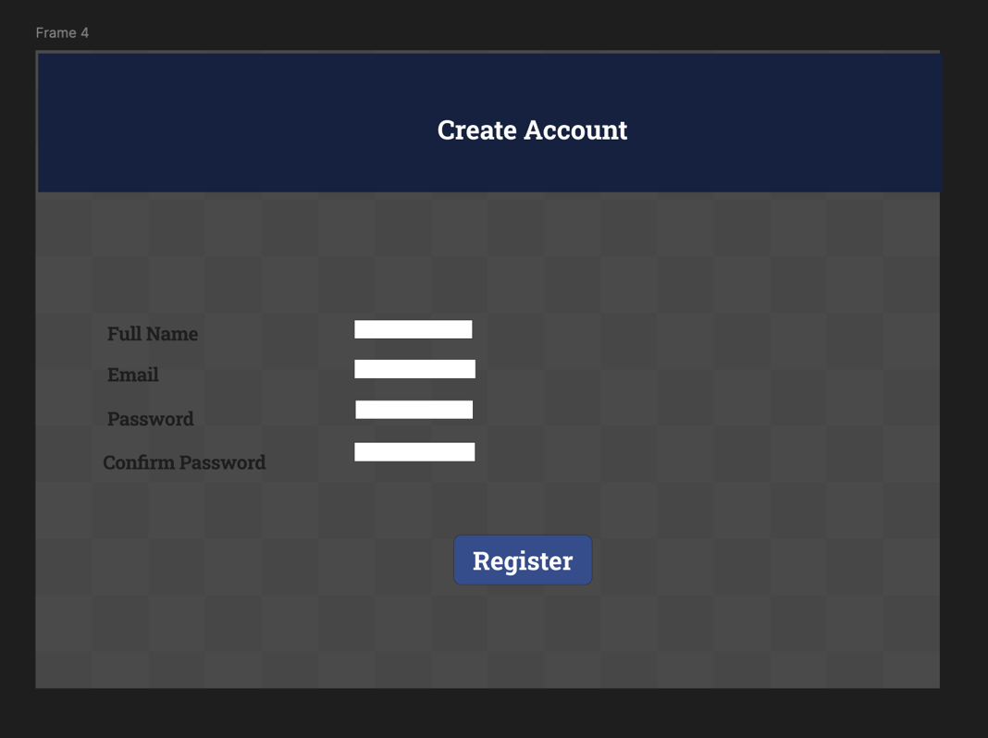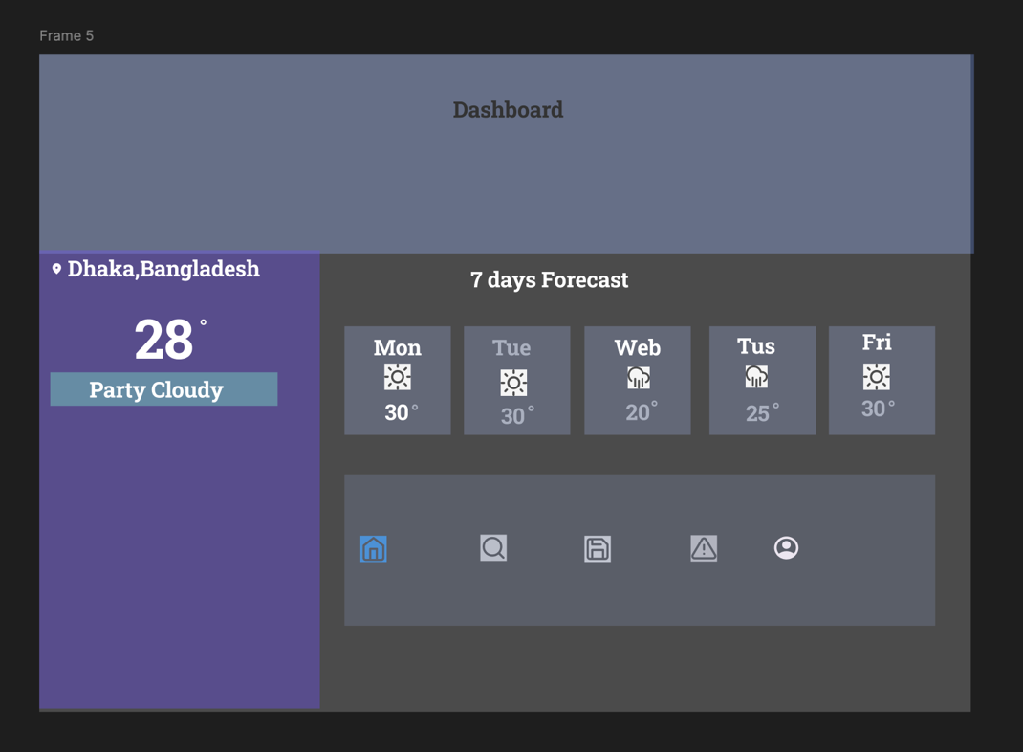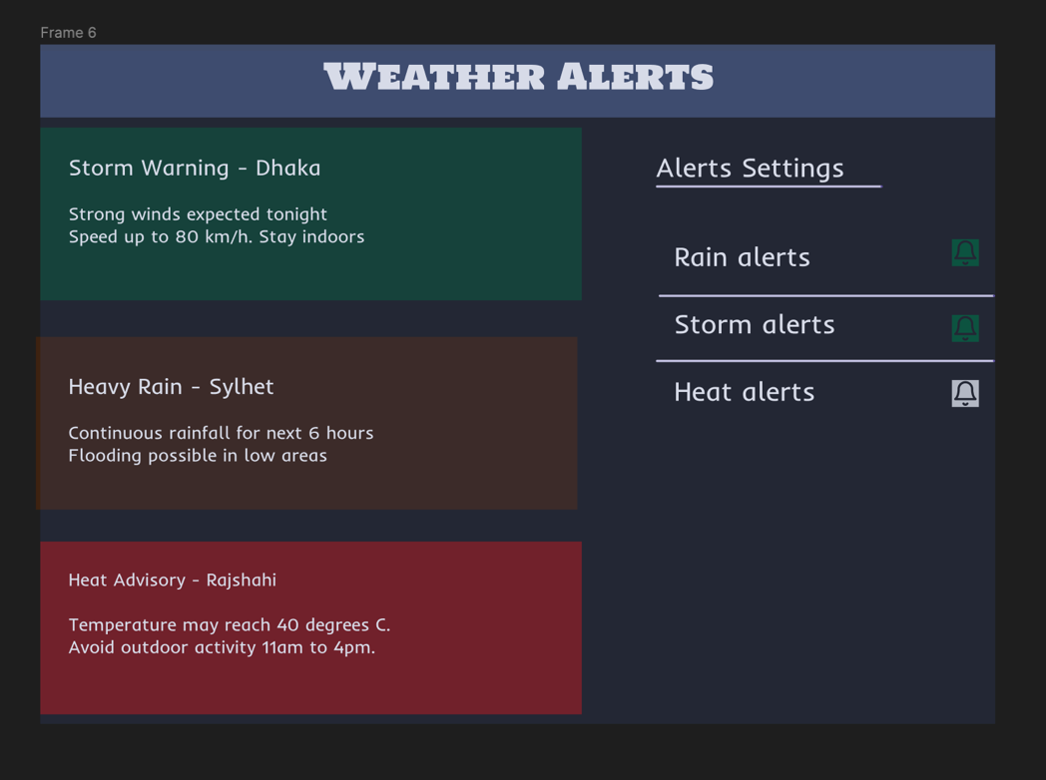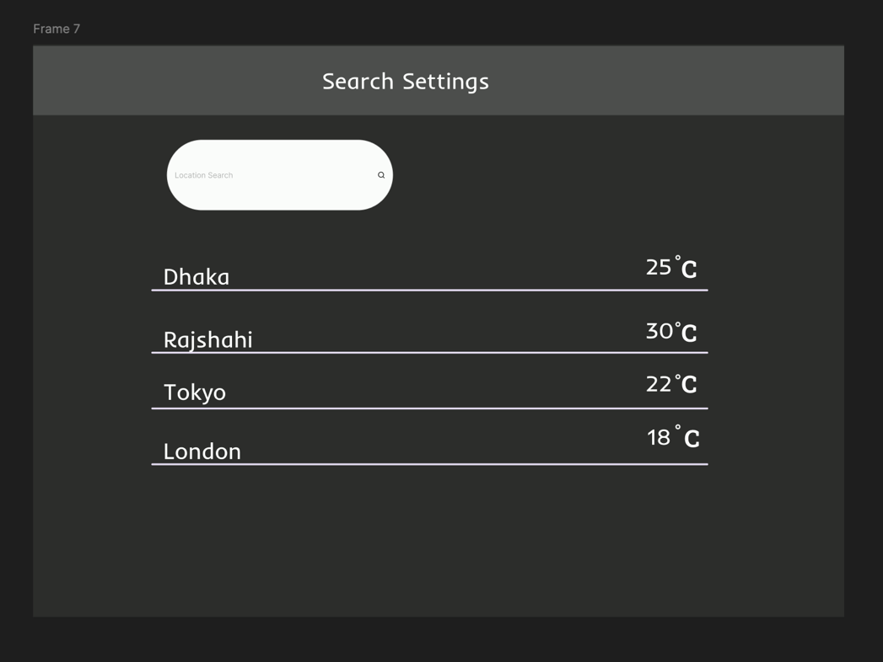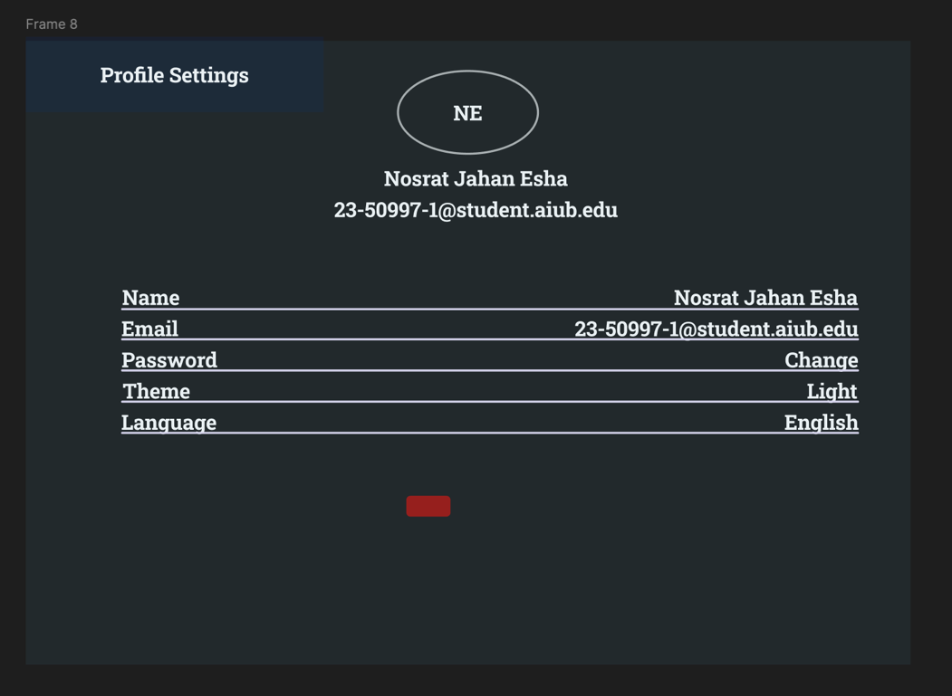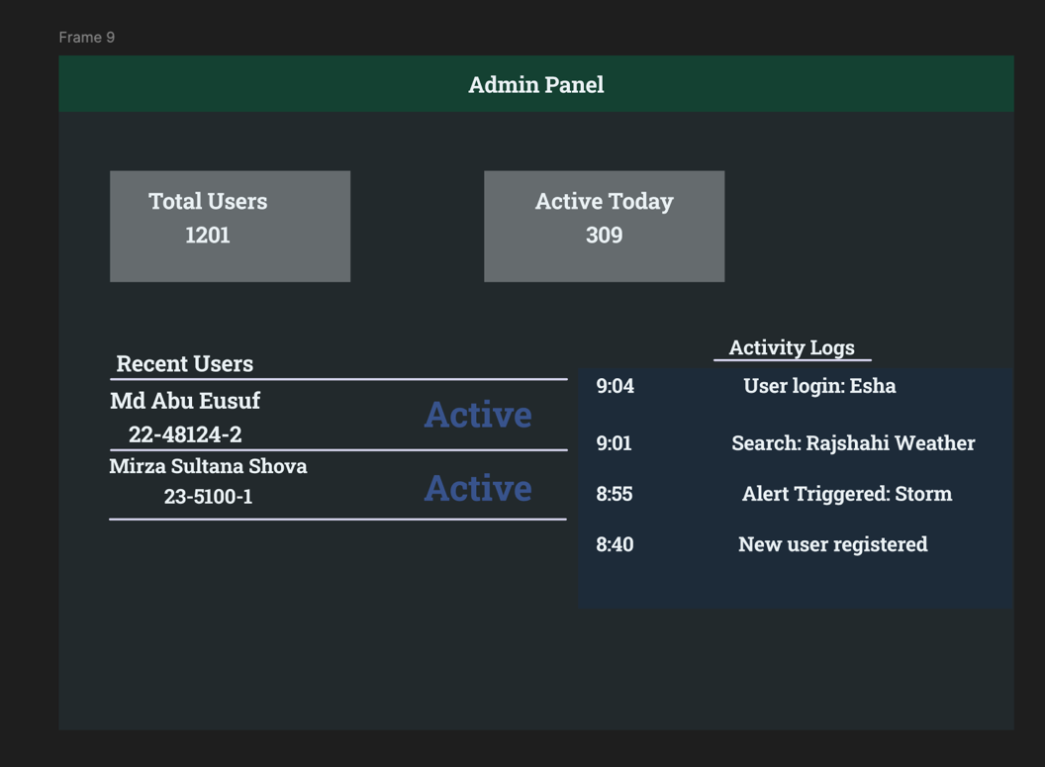

5. GIT WORKFLOW
- Create a central repository for the project on GitHub and set the master (or main) branch as the primary branch for integration.
- Each member should clone the repository and create their own feature branches for assigned tasks. Work on new features or fixes within these branches.
- Add files based on Trello cards, stage them and commit changes with clear messages that describe the purpose of each update. The text files (where the card serial, description are available based on Trello board) should be uploaded in the Git repository.
- Push commits from the feature branches to the remote repository so other members can see progress.
- Use pull to fetch and integrate changes from the remote repository into local copies, ensuring everyone stays updated.
- Merge feature branches into the master/main branch only after the work is tested and reviewed, resolving any conflicts that occur.
- Show evidence of collaboration by maintaining a clear commit history (using logs) with multiple commits, merges and contributions from all group members.
- Keep the repository organized with a clean history that tracks the project workflow from initialization to completion.
- Lastly, add the “Final Trello Board” screenshot in this section.

6. SOFTWARE TESTING
Test Case 1: User Registration
Project Name: Real-Time Weather Monitoring System
Test Case ID: FR_TC_01 |  |  | Test Designed by: MIRZA SULTANA YEASMIN SHOVA
Test Priority: High |  |  | Test Designed date: 2026-05-13
Module Name: User Registration |  |  | Test Executed by: NOSRAT JAHAN ESHA
Test Title: Verify user registration with valid and invalid input data |  |  | Test Execution date:
Test Scenario: Check that users can register successfully using valid information and receive proper validation messages for invalid inputs.

Preconditions:
- Internet connection is active
- Application server is running
- Registration page is accessible

Dependencies:
- Database connection active
- Backend authentication service running
- Email validation service enabled
Test Steps | Test Data | Expected Result | Actual Result | Status
- Open the registration page | URL: https://weather-app.com/register | Registration form opens successfully | Registration page loaded successfully in Chrome browser | Pass
2. Enter valid user information | Name: Shova Mirza  Email: shova122@gmail.com Password: Weather@123 Confirm | User information accepted successfully | All input fields accepted valid information correctly | Pass
3. Click the Submit button | Valid registration form | User account created successfully | Account created and redirected to dashboard page | Pass
4. Enter invalid email format | Email: shova.com | Validation error displayed for invalid email | Error message shown below email field | Pass
5. Enter weak password | Password: 12345 | Password security warning displayed | Weak password warning displayed successfully | Pass
6. Enter mismatched passwords | Password: Weather@123 Confirm Password: Weather@321 | Password mismatch error displayed | Password mismatch error displayed correctly | Pass
7. Leave required input fields empty | Empty Name/Email/Password fields | Required field validation triggered | Required field messages displayed for all empty fields | Pass
Test Case 2: User Login
Project Name: Real-Time Weather Monitoring System
Test Case ID: FR_TC_02 |  |  | Test Designed by: NOSRAT JAHAN ESHA
Test Priority: High |  |  |  | Test Designed date: 2026-05-13
Module Name: User Login |  |  |  | Test Executed by: SHOVA MIRZA
Test Title: Verify secure user login with valid and invalid credentials |  |  |  | Test Execution date:
Test Scenario: Check that users can log in successfully using valid credentials and receive appropriate error messages for invalid login attempts.

Preconditions:
- Registered user account exists
- Application server is running
- Internet connection is active

Dependencies:
- Authentication service running
- Database connection active
- Login page accessible
Test Steps | Test Data | Expected Result |  | Actual Result | Status
1. Open the login page | URL: https://weather-app.com/login | Login page opens successfully |  | Login page loaded successfully in Chrome browser | Pass
2. Enter valid login credentials | Email: user@test.com Password: Weather@123 | User credentials accepted |  | Valid credentials entered successfully | Pass
3. Click the Login button | Valid login form | User logged into dashboard successfully |  | User redirected to dashboard after successful login | Pass
4. Enter invalid password | Email: user@test.com Password: Wrong123 | Error message displayed for incorrect password |  | Invalid credential error message displayed correctly | Pass
5. Enter unregistered email | Email: unknown@test.com | System rejects unregistered account |  | Account not found message displayed | Pass
6. Leave login fields empty | Empty Email and Password fields | Required field validation triggered |  | Validation messages displayed for empty fields | Pass
7. Click Forgot Password option | Registered Email | Password reset process initiated |  | Password reset page opened successfully | Pass

Test Case 3: Search Weather
Test Case ID: FR_TC_03
Test Priority: High |  |  | Test Designed by: SHOVA MIRZA
Module Name: Search Weather |  |  | Test Designed date: 2026-05-13
Test Title: Verify weather search functionality using valid and invalid city names |  |  | Test Executed by: NOSRAT JAHAN ESHA
Project Name: Real-Time Weather Monitoring System |  |  | Test Execution date:
Test Scenario: Check that users can search weather information using city names and receive correct weather results or proper error messages for invalid locations.
Preconditions:
- Internet connection is active
- Weather API service is running
- User is on dashboard or search page
Dependencies:
- External Weather API available
- Database/server connection active
- Search module functioning properly
Test Steps | Test Data | Expected Result | Actual Result | Status
1. Open the weather search page | URL: https://weather-app.com/search | Search page opens successfully | Weather search page loaded successfully in Chrome browser | Pass
2. Enter a valid city name in search bar | City: Dhaka | Correct weather information displayed | Temperature, humidity, and weather condition displayed correctly for Dhaka | Pass
3. Click the Search button | Search input: Dhaka | Weather data fetched successfully | Weather details loaded within 2 seconds | Pass
4. Verify displayed weather details | Weather Result Panel | Temperature, humidity, and wind speed visible | All weather details displayed correctly with icons | Pass
5. Search another valid location | City: Chittagong | Correct weather data displayed for selected city | Accurate weather information shown for Chittagong | Pass
6. Enter an invalid city name | City: xyz123abc | Error message displayed for invalid location | “Location not found” message displayed properly | Pass
7. Leave search field empty and click search | Empty input field | Validation warning displayed | “Please enter a city name” warning shown | Pass
8. Verify search responsiveness on mobile device | Mobile/Tablet View | Search UI adapts properly on smaller screens | Search bar and result section adjusted correctly on mobile screen | Pass

Test Case 4: Current Weather
Test Case ID: FR_TC_04
Test Priority: High |  |  | Test Designed by: NOSRAT JAHAN ESHA
Module Name: Current Weather |  |  | Test Designed date: 2026-05-13
Test Title: Verify real-time current weather information display |  |  | Test Executed by: ABU YOUSUF
Project Name: Real-Time Weather Monitoring System |  |  | Test Execution date:
Test Scenario: Check that the system displays accurate real-time weather information including temperature, humidity, wind speed, and weather condition icon from the weather API.
Preconditions:
- Internet connection is active
- Weather API service is running
- User is logged into the system
Dependencies:
- API integration service active
- Dashboard module running
- Weather database/API accessible
Test Steps | Test Data | Expected Result | Actual Result | Status
1. Login to the system and open dashboard | Valid user credentials | Dashboard opens successfully | Dashboard loaded successfully after login | Pass
2. Open Current Weather panel | N/A | Current weather section displayed | Current Weather panel displayed correctly | Pass
3. Verify temperature display | API Weather Data | Current temperature displayed correctly | Temperature displayed as 31°C from API response | Pass
4. Verify humidity display | Humidity: 78% | Humidity value displayed correctly | Humidity displayed correctly in weather panel | Pass
5. Verify wind speed display | Wind Speed: 14 km/h | Wind speed displayed correctly | Wind speed shown correctly from API data | Pass
6. Verify weather condition icon | Weather Condition: Rainy | Appropriate weather icon displayed | Rain icon displayed correctly based on API condition | Pass
7. Refresh weather data | Refresh Button | Weather data updates in real-time | Weather information refreshed successfully | Pass
8. Compare displayed data with API response | Live API Response | UI data matches API response accurately | Displayed weather information matched API response | Pass

Test Case 5: Weather Forecast
Test Case ID: FR_TC_05
Test Priority: High |  |  | Test Designed by: SHOVA MIRZA
Module Name: Weather Forecast |  |  | Test Designed date: 2026-05-13
Test Title: Verify 7-day and hourly weather forecast display |  |  | Test Executed by: ABU YOUSUF
Project Name: Real-Time Weather Monitoring System |  |  | Test Execution date:
Test Scenario: Check that the system correctly displays 7-day weather forecast, hourly forecast, and graphical representation based on API data.
Preconditions:
- Internet connection is active
- Weather API service is running
- User is logged into the system
Dependencies:
- Forecast API integration enabled
- Dashboard module available
- Chart/graph rendering library active
Test Steps | Test Data | Expected Result | Actual Result | Status
1. Login to the system and open dashboard | Valid user credentials | Dashboard loads successfully | Dashboard opened successfully after login | Pass
2. Navigate to Weather Forecast section | N/A | Forecast section displayed | Weather Forecast panel opened correctly | Pass
3. Verify 7-day forecast display | API Forecast Data | 7-day forecast shown clearly | 7-day forecast displayed with correct dates and conditions | Pass
4. Verify hourly forecast display | Hourly API Data | Hourly forecast displayed properly | Hourly weather data shown correctly for current day | Pass
5. Check weather icons in forecast | Sunny/Rainy/Cloudy conditions | Correct icons displayed for each day | Weather icons matched API conditions accurately | Pass
6. Verify temperature range display | Min/Max Temperature | Min and max values displayed correctly | Temperature range shown properly for all days | Pass
7. Verify forecast chart/graph rendering | Graph Data from API | Graph loads without error | Forecast graph rendered successfully | Pass
8. Refresh forecast data | Refresh Action | Updated forecast data displayed | Forecast data refreshed correctly from API | Pass

Test Case 6: Profile Management
Test Case ID: FR_TC_6
Test Priority: High |  |  | Test Designed by: ABU YOUSUF
Module Name: Profile Management |  |  | Test Designed date: 2026-05-13
Test Title: Verify user profile viewing, updating information, and password changing functionality |  |  | Test Executed by: SHOVA MIRZA
Project Name: Real-Time Weather Monitoring System |  |  | Test Execution date:
Test Scenario: Check that users can successfully view profile information, update account details, and change password with proper validation.
Preconditions:
- User account exists
- User is logged into the system
- Internet connection is active
Dependencies:
- User authentication service active
- Database connection running
- Profile management module enabled
Test Steps | Test Data | Expected Result | Actual Result | Status
1. Login to the system | Valid user credentials | User logged in successfully | User logged into dashboard successfully | Pass
2. Open Profile Management page | N/A | Profile page displayed successfully | Profile management page opened correctly | Pass
3. Verify user profile information | User Name, Email, Profile Details | Existing profile information displayed correctly | User profile information displayed accurately | Pass
4. Update profile information | Name: Shova Mirza Email: shova@test.com | Updated information saved successfully | Profile information updated successfully in database | Pass
5. Refresh profile page | Updated user data | Updated information remains visible | Updated profile details remained saved after refresh | Pass
6. Enter valid new password | Current Password: Weather@123 New Password: NewWeather@456 | Password updated successfully | Password changed successfully | Pass
8. Enter incorrect current password | Current Password: Wrong123 | Error message displayed | Incorrect password error displayed properly | Pass
9. Logout and login using new password | New Password: NewWeather@456 | Login successful with new password | User logged in successfully using updated password | Pass

Test Case 7: Admin Login
Test Case ID: FR_TC_7
Test Priority: High |  |  | Test Designed by: NOSRAT JAHAN ESHA
Module Name: Admin Login |  |  | Test Designed date: 2026-05-13
Test Title: Verify secure admin login functionality |  |  | Test Executed by: SHOVA MIRZA
Project Name: Real-Time Weather Monitoring System |  |  | Test Execution date:
Test Scenario: Check that only authorized admins can access the admin panel using valid credentials and unauthorized access is restricted.
Preconditions:
- Internet connection is active
- Admin account exists in the system
- Admin portal is accessible
Dependencies:
- Backend authentication service running
- Database connection active
- Session management service enabled
Test Steps | Test Data | Expected Result | Actual Result | Status
1. Open the admin login page | URL: https://weather-app.com/admin | Admin login page opens successfully | Admin login page loaded successfully in browser | Pass
2. Enter valid admin credentials | Email: admin@test.com Password: Admin@123 | Admin credentials accepted | Valid admin credentials accepted successfully | Pass
3. Click Login button | Valid admin login form | Admin redirected to admin dashboard | Admin dashboard opened successfully | Pass
4. Enter incorrect password | Password: wrong123 | Error message displayed | Invalid credential error displayed correctly | Pass
5. Attempt login with non-admin account | User Account Credentials | Access denied for normal user | System restricted unauthorized access | Pass
6. Leave login fields empty | Empty Email and Password | Required field validation triggered | Validation messages displayed for empty fields | Pass
7. Verify secure session creation after login | Valid admin session | Secure admin session created | Admin session created successfully with secure token | Pass
8. Attempt direct access to admin dashboard without login | URL: https://weather-app.com/admin/dashboard | Unauthorized access blocked | System redirected user to admin login page | Pass

Test Case 8: User Management
Test Case ID: FR_TC_8
Test Priority: High |  |  | Test Designed by: ABU YOUSUF
Module Name: User Management |  |  | Test Designed date: 2026-05-13
Test Title: Verify admin can manage users successfully |  |  | Test Executed by: SHOVA MIRZA
Project Name: Real-Time Weather Monitoring System |  |  | Test Execution date:
Test Scenario: Check that the admin can view users, delete users, and manage user roles successfully from the admin control panel.
Preconditions:
- Admin account is available
- Application server is running
- User records exist in the database
Dependencies:
- Admin authentication service active
- Database connection active
- User management module running
Test Steps | Test Data | Expected Result | Actual Result | Status
1. Login to the admin panel | Admin Email: admin@weather.com Password: Admin@123 | Admin login successful | Admin dashboard opened successfully | Pass
2. Open User Management section | N/A | User management page displayed | User management section loaded correctly | Pass
3. View registered users list | Existing user records | All users displayed properly | Registered user list displayed successfully | Pass
4. Search for a specific user | User: test_user01 | Selected user displayed correctly | Specific user found successfully in search result | Pass
5. Delete a user account | User ID: U102 | User account deleted successfully | Selected user removed from database successfully | Pass
6. Verify deleted user removal | Deleted User Record | Deleted user no longer visible | Deleted user removed from user list correctly | Pass
7. Change user role | Change role from User to Moderator | User role updated successfully | User role updated and saved correctly | Pass
8. Refresh user management page | N/A | Updated user data displayed | Latest user information displayed correctly | Pass

7. CONCLUSION
- Write a conclusion within 180 to 200 words.

Instructions:
- Minimum of 3 members and Maximum of 5 members per group.
- Font: Times New Roman ; Size: 12; Justify the para [Ctrl + J].
- Delete the highlighted part after completing this project report.
- The completed report should be within the range of 40 to 50 pages.

- Submission: Bring a hard copy of this report [per group] on the project evaluation day. Also, you will need to upload the soft copy later.

